Accounting : Executive Reports – Time Analysis-Oct to Sept SOP

**Objective/Purpose/ Why:** This report is generated from Deltek Vision and provides a running total of the performance metrics by Group (Practice Area) and Discipline for each employee and is presented at the weekly meeting every Monday. The Performance Period runs from October through September and is used for employee reviews, compensation, bonuses, etc.

**Outcome:** The final report is presented to the Executive and Management members by the CEO at the weekly Executive Meeting currently scheduled for Monday afternoon.

**Process:** Once timesheets have been posted in Deltek Vision for the prior week the Executive Reports are produced to provide data that is reviewed in the meeting. This report uses a saved report template that is updated for the period just ended. Specifically, the date range will include all the payroll periods covered in the Performance Period that have passed. So that, during the entire Performance Period, the “from” date will remain the same until that Period ends next September and the “Calculate STD Hrs as of” and “to” dates will change every week to include the week just ended. The exact dates of the Performance Period will change every year depending on the payroll weeks.

1. **GENERATE REPORT IN VISION**:

► **REPORTING**

► **EMPLOYEE**

* **2019 Standard -** **Time Analysis Dollar Weighted Oct to Sept Prac**
* Under the “Options” column open the field for more options using the 3-dot icon (ellipsis) to the right (1.)

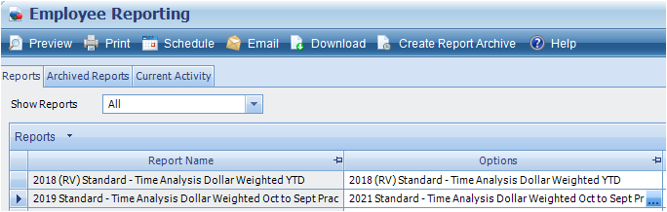

**1.**

* At the report Options (bottom of pop-up screen), select the dropdown
* and choose Global Options, then the report name:

**2021 Standard – Time Analysis Dollar Weighted Oct to Sept Prac**

* In the **General** tab update the following dates:
  + Calculate STD Hrs as of = payroll period just ended on Sunday (1.)
  + Print Current, Date Range:
    - beginning date = beginning of performance period in September (2.)
    - ending date = payroll period just ended on Sunday (3.)

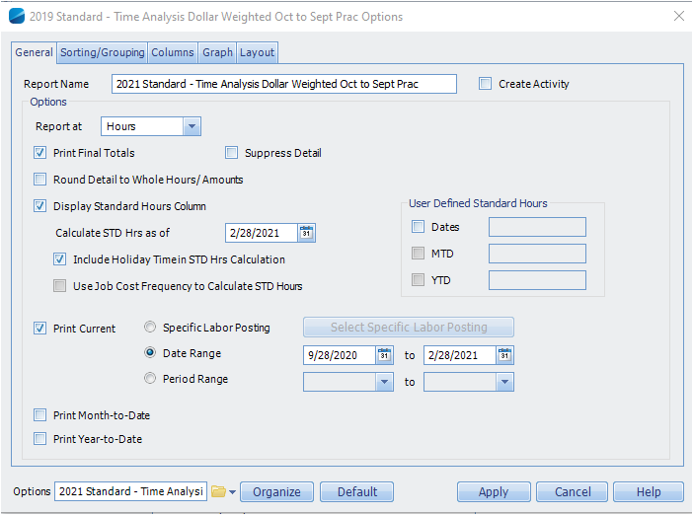

**1.**

**2.**

**3.**

* In the **Sorting/Grouping** tab – select the fields as shown below in the same order (these options will remain as is every time this report is selected).

* In the **Columns** tab – select the fields as shown below in the same order (these options will remain as is every time this report is selected).

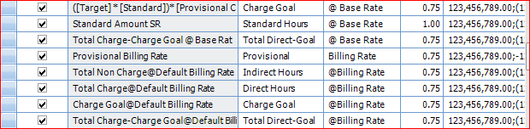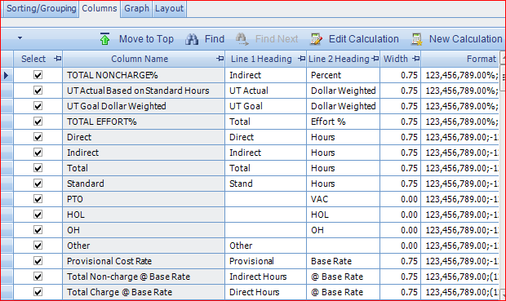

* Save the current parameters:
  + Organize (4.), Folder Name = Global Options (5.)
  + Save Name = 2021 Standard – Time Analysis Dollar Weighted Sep to Oct Prac (6.), Save (7.), then Yes (Option already exists in that folder. Would you like to replace this option?)

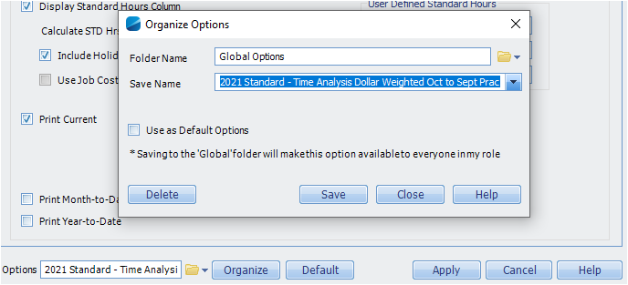

**4.**

**5.**

**6.**

**7.**

**8.**

* Apply the current parameters (8.)
* 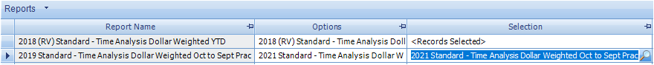Back on the Employee Reporting screen, at the column “Selection”, open the field for more options using the magnifying glass to the right (1.)

**1.**

* 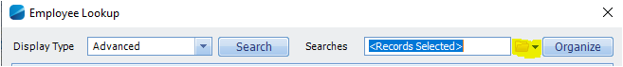Select the Searches dropdown

and choose Global Searches then the report name:

**2021 Standard – Time Analysis Dollar Weighted Oct to Sept Prac**

* Apply the current parameters (2.)

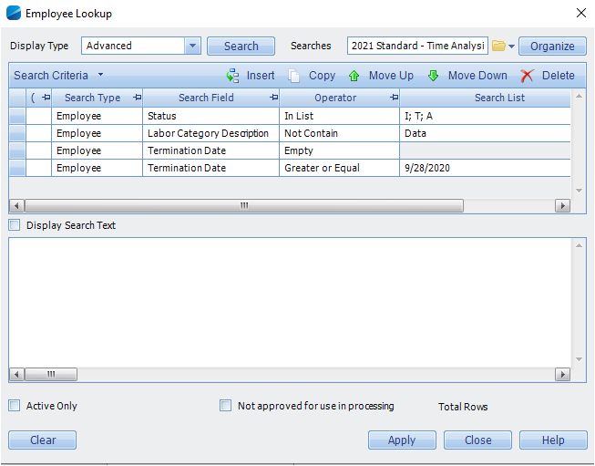

**2.**

* Graphical user interface, text, application

  Description automatically generatedTo generate the report, on the Employee Reporting screen, choose Preview
* Text

  Description automatically generatedWhen the report opens, choose the Download command
* Graphical user interface, text, application

  Description automatically generatedAt the Download pop-up options menu choose “Microsoft Excel Spreadsheet” and then Open
* Once the report opens in Excel save the original as is for possible future use or reference

1. **EDIT REPORT IN EXCEL**:

► **FORMATTING**

* **Tabs:**
* Graphical user interface, application, table, Excel

  Description automatically generatedDocument map – right click on tab name and Hide
* Sheet2 through Sheet5 – double click on each tab and Rename them:
  + ADMIN
  + EGDV
  + PLDV
  + TOTAL

*Originally there existed another Practice Area (Timesheet Group), DATA. For the remainder of the 2020-2021 Performance Period, a “DATA” tab will appear as Sheet3 with one prior employee. This tab can be deleted or hidden.*

* Graphical user interface, application, Teams

  Description automatically generated**Sheets:**
* Table

  Description automatically generated with low confidenceGroup all sheets; select the top leftmost cell with the “Select All” triangle and then remove Wrap Text and Merge & Center under the Home section. Ungroup the sheets.
* **ADMIN** - On the ADMIN tab highlight columns A – Z and adjust the width of the columns so that all the hidden columns appear. Delete columns B, H, I, S, W and X. Adjust the height on row 2 so that the title is shown.
* **EGDV, PLDV, TOTAL** – Group the other three sheets and highlight columns A – W, then adjust the width and delete columns G, H, and T. Ungroup the sheets.
* **all** - Regroup all four sheets again and set column widths: Column A = 35, columns B – I = 8, columns K – O and Q – T = 10, columns J and P = 9 and then ungroup sheets. Reformat the header rows: on the ADMIN tab highlight the header row and then select: Center, Middle Align, and Wrap Text; group the other 3 tabs, highlight the header rows and perform the same operations.

► **EDITING**

* **Inactive and Terminated Employees:**
* On every sheet hide the rows with inactive and terminated employees. Also hide the rows containing employees with no activity.
* **Weighted formula cells:**
* Open the prior week’s report and copy the cells in columns A – D containing the subtotals and totals (yellow highlighted cells in the example below). *The formulas in the cells reference cells on that same row so you can copy once and paste multiple times on every sheet.* Paste these cells for every Active subtotal row, Discipline subtotal row and once for the Practice Area (Timesheet Group) total row.
* Table

  Description automatically generated with medium confidenceCopy the Hours Weighted %, Charge Goal for the year and comparison cells from the prior report (in red box below) and paste at the bottom of the spreadsheet. Be careful to copy these rows from the original report for EACH SHEET as the Charge Goal percentage is specific to each particular Practice Area as well as the Total sheet.

► **SAVING** – Save report as:

**2021 Standard - Time Analysis Dollar Weighted Oct to Sept Prac yyyymmdd**

1. **DISTRIBUTE REPORT**:

► **Deadline** – Provide the report to the management team at least 30 minutes before the start of the Executive Management meeting at 2:00 pm.

► **Save in Management Meetings folder** – Save a copy of the report in the folder:

**Z:\Reports\Management Meetings**

► **Email** – Create a new email, copy all information from prior week’s email, update for the current period, attach the report, along with the YTD report, and send.

**Subject Matter Experts:** General questions regarding the report structure are referred to the Controller (Kim McDonald). The Executive and Management team members provide feedback concerning the useability and accuracy of the data.

**Definitions:**

Time Weighted Percentages – In this report the time weighted percentage formulas are calculated by applying the standard hours (rather than the total hours) to the direct and indirect hours in turn.

Dollar Weighted Percentages – In this report the dollar weighted percentage formulas are calculated by applying the standard hours x base rate (rather than the total hours x base rate) to the direct and indirect hours x base rate in turn. These formulas are inserted manually after the report has been generated (yellow highlighted cells).

UT Goal – The UT goal is the percentage of hours each employee is expected to devote to billable time based on the standard hours of 40 hours per week (or actual hours per week if part time or temporary).

Performance Period – The annual cycle period selected by the CEO that is used to calculate employee utilization to assist managers during employee reviews and to determine bonuses and future compensation.